Chapter 3, Solution 63

Find v_{x}, and i_{x} in the circuit shown in Fig. 3.107.

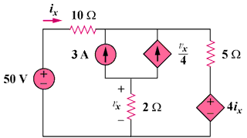

Figure 3.107
For Prob. 3.63.

Solution
–
+

50 V

4i_{x}
+
–

i₁

i₂

10 Ω

5 Ω

A

For the supermesh, -50 + 10i₁ + 5i₂ + 4i_{x} = 0, but i_{x} = i₁. Hence,

50 = 14i₁ + 5i₂ (1)

At node A, i₁ + 3 + (v_{x}/4) = i₂, but v_{x} = 2(i₁ – i₂), hence, i₁ + 2 = i₂ (2)

Solving (1) and (2) gives i₁ = 2.105 A and i₂ = 4.105 A

v_{x} = 2(i₁ – i₂) = –4 volts and i_{x} = i₂ – 2 = 2.105 amp

